PRIMARY PRINCIPALS’ SABBATICAL REPORT

TERM 3 2011

“Effective Teaching in a Global Networked Society”



Cyril Nevezie
Principal
Stanhope Road School
Harris Rd
Mt Wellington
Auckland

Retired April 2012

CONTENTS:

Page | Topic
3 | Introduction - How the sabbatical evolved.
4 | Timeline
5 | The EARLI Conference
10 | School Visits - London
12 | School Visits - NZ
18 | Summary & Conclusions

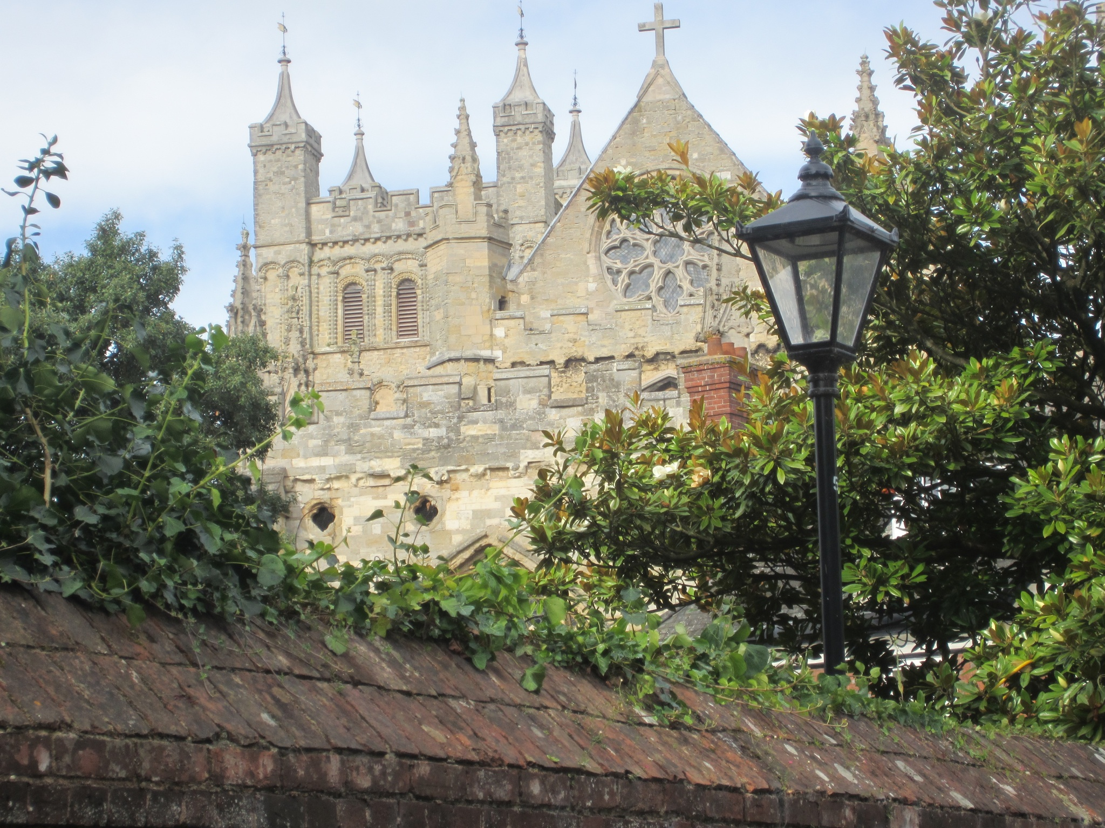

The Great Cathedral of Exeter
England

Introduction

When I applied for this sabbatical in 2010 I had no idea that I would be retiring two terms after the completion of the sabbatical. Our school had recently completed an ICTPD contract with the facilitation of Pam Hook and Julie Mills from “HookED”. I felt that it would be good to extend my own learning, with visits to schools that had also implemented SOLO into their curriculum. This aspiration was reflected in my application.

However, by the time I had been approved for my sabbatical and the school had been through another ERO visit early in 2011, my focus had changed. I was still interested in seeing how ICT could enhance learning throughout the school, but I was becoming more focussed on exploring ways of enhancing leadership throughout the school. I was also influenced by the fact that I discovered that the timing of my visit to England coincided with the end of the long summer break and that schools were not available for visits. They were busy with planning and preparations for the beginning of a new school year. Flexibility in my thinking and planning was required.

I spent the start of my sabbatical time rethinking the overall organization of my time and a new direction for the originally planned school visits. My initial time was used to make contacts and arrange visits both in England and in NZ. I also read the steady flow of information and professional readings sent from the organizers of the EARLI Conference. I quickly realized that this conference was going to be unlike any that I had ever attended as a principal.

The cornerstone of my sabbatical was the Conference in England, based at the campus of the University of Exeter. When planning my application I used the Internet, to see what kind of conferences were likely to be available, during the proposed leave period. It quickly became apparent that little detailed information was available, when I began the research well over a year out. However, I was able to read about prior conferences of various types and was able to predict what was likely to be available at that time during 2011. I was also feeling a bit jaded with the regular type of Principal’s Conferences I had attended over many years. I felt that I would like some intellectual challenge and recalled the pleasure that I had experienced in returning to MA studies as a mature student, several years earlier. When I found the EARLI website, my curiosity was piqued. I realized that if I chose to attend that conference I was likely to be well out of my comfort zone.

I was also very aware that this sabbatical represented an opportunity for refreshment - an important consideration after more than twenty-four years as a principal. I therefore tried to build in a fifty-fifty balance of study and recreation. Although the timetable does not fully reflect it, portions of time set aside for recreation involved readings, emails, phone calls and the general organization and preparation related to the sabbatical study.

TIMELINE

The eventual format of the term’s sabbatical leave was follows:

- Wks 1 - 3: Completion of trip planning; readings related to the conference.

- Wk 4: Travel to London arriving on 14 Sept. Initially this time was spent relaxing and sightseeing. Some time was also spent in preparation for the conference. An enormous electronic version of the Conference Programme had arrived via email and it took a great deal of time, skimming through it learning how the conference was organized and how to book in for selected sessions and keynote speakers.
- Wk 5: Travelled to Exeter by train on 28 August and attended the Conference Tuesday - Saturday.

- Wks 6 & 7: Returned to London by train, had one day of preparation and set off on a road to trip to Scotland. Returned to London and made two school visits. Departed Heathrow 14 September. Returned to NZ via Bangkok.

- Wk 8: Visited Bailey Rd & Meadowbank Schools

- Wk 9: Had two further school visits planned in Auckland but had to cancel.

- Wk 10: Road trip to Hawkes Bay via Hamilton. Visited three schools in Hamilton area and two schools in Hastings.

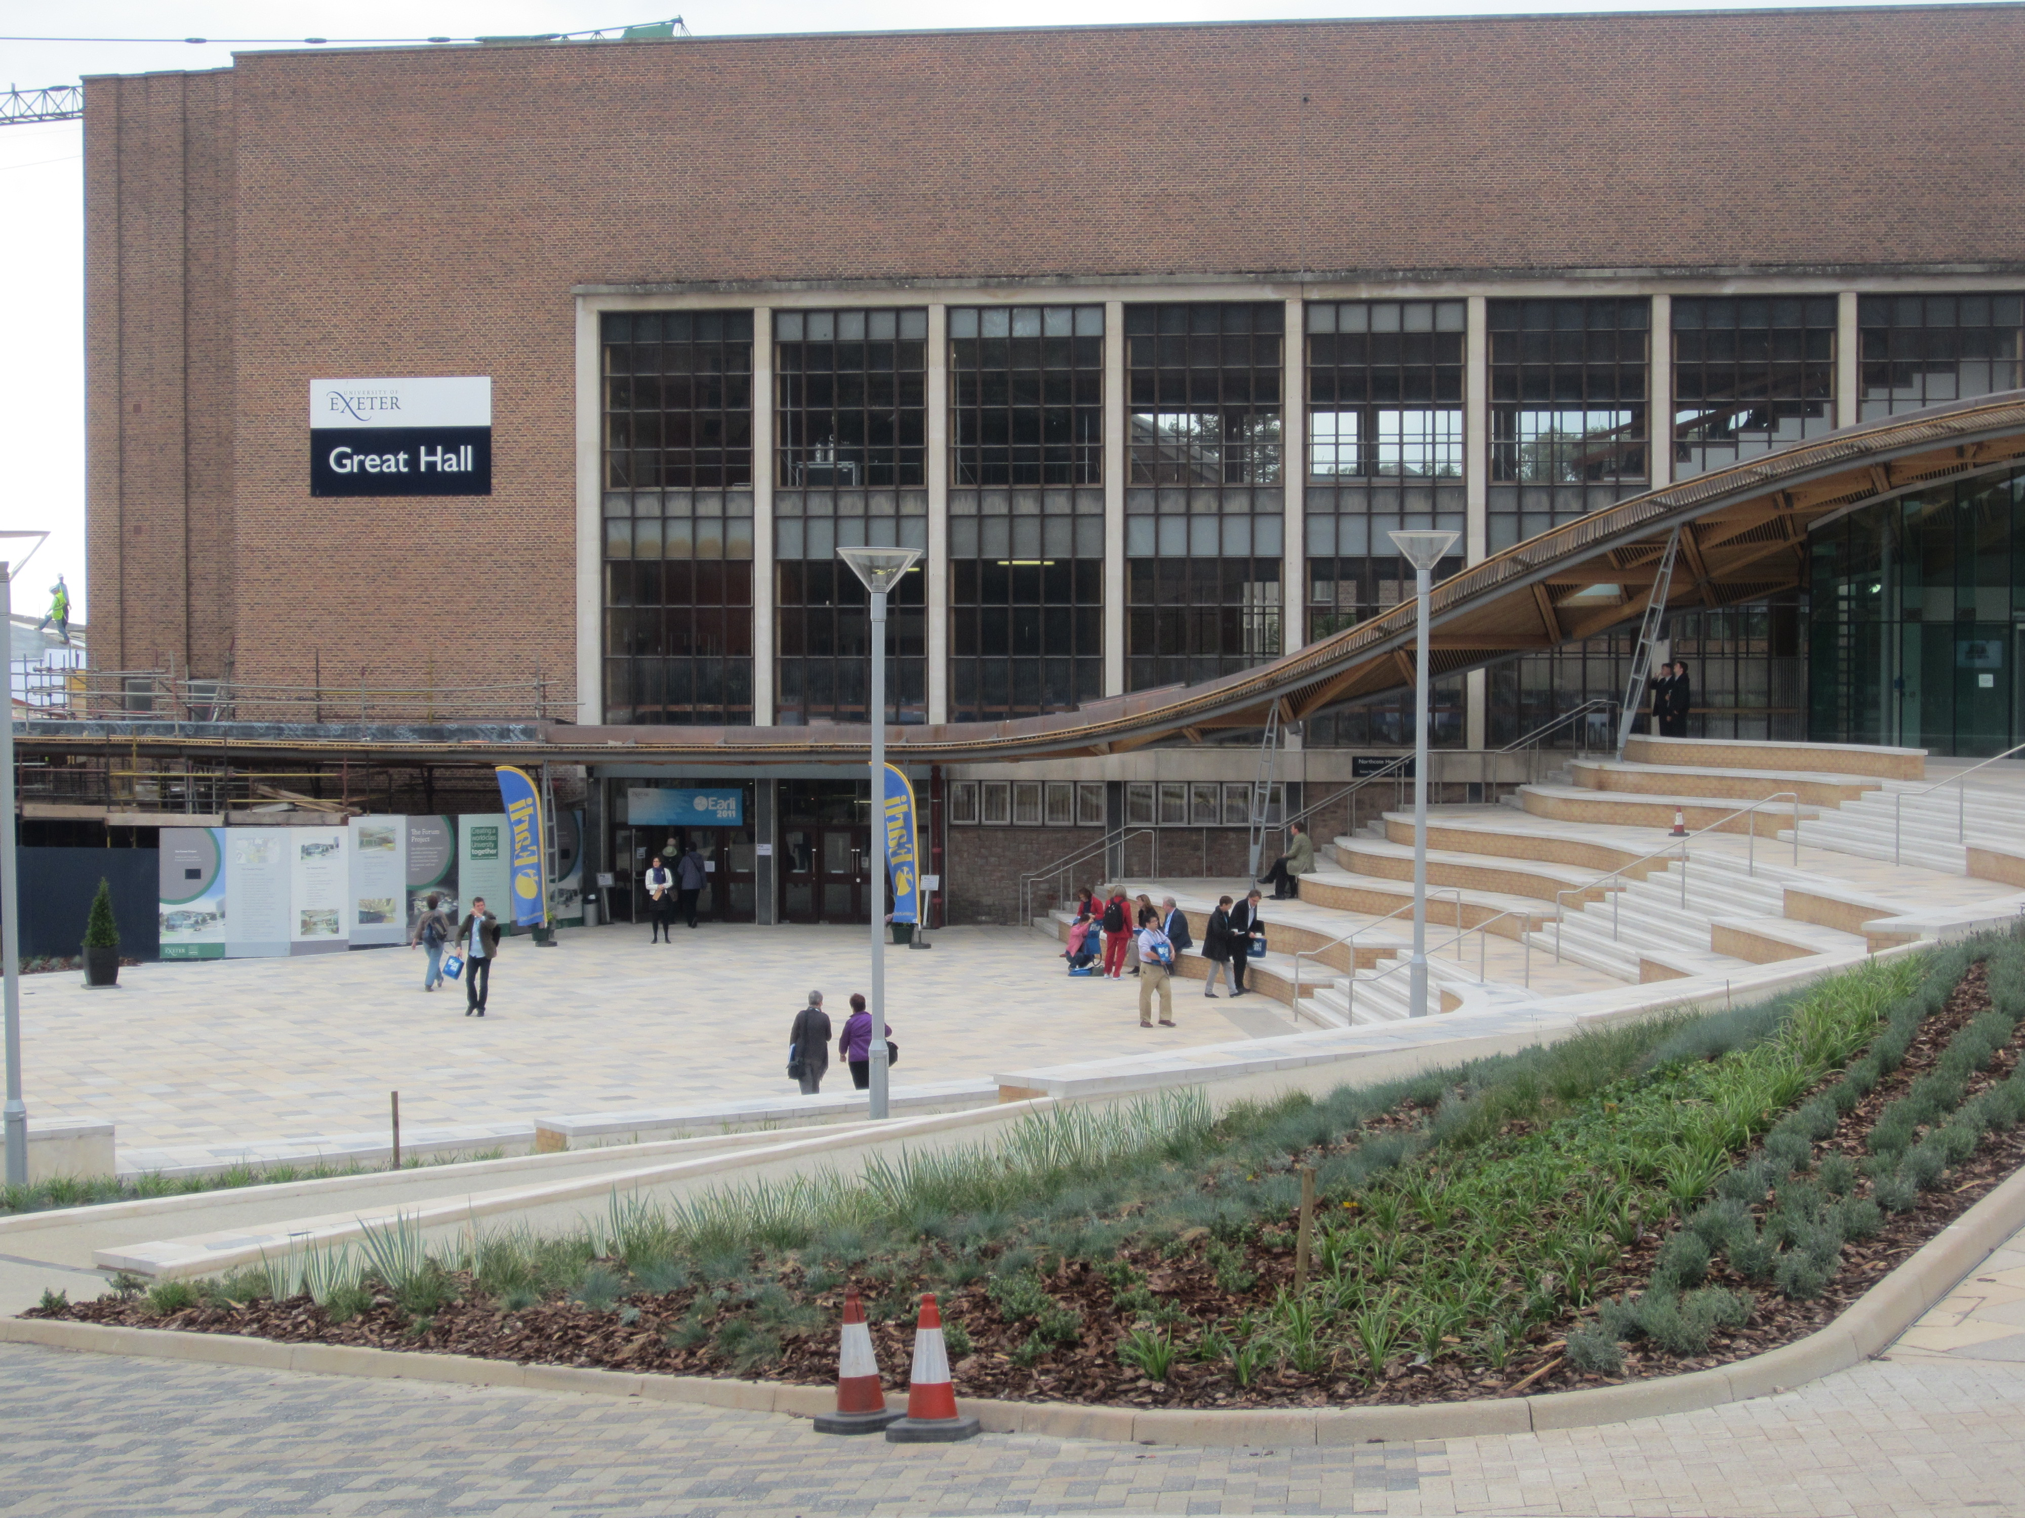
Brand-new Great Hall at Exeter University
EARLI CONFERENCE 2011 - EXETER UNIVERSITY

Background Information

The EARLI Conference is a biennial one and a truly international one. When one looks at the lengthy lists of organizing committees one can see that delegates and committee members represent most parts of the world academic community. The emphasis is on sharing and disseminating the latest educational research and providing opportunities for research teams to have their work scrutinized and peer reviewed by colleagues. It is a very busy and intense environment during the week of the conference with a huge amount of research being presented in a very wide variety of ways. Before the main conference there was a minor pre-conference for more junior researchers to share their findings in a more informal atmosphere, called JURE 2011. Throughout the conference, members of the 22 SIG groups met to discuss their own special interest areas in greater detail and to network with like-minded researchers.

During the course of the conference I did not meet any school principals or current teachers. I doubt there were any in attendance, other than me. The participants seemed to be predominantly academics working in universities or research institutions. Some were from education faculties similar to our former Teachers Colleges. The research teams who were presenting to the conference were largely PhD students or those who had recently graduated and were on post-graduate fellowships. The teams were generally guided and led by senior academic staff such as professors and research scientists who specialized in fields such as research on the brain. There are also regular publications of EARLI research journals online which provide an ongoing means of disseminating and reviewing current research between and during the biennial conferences. I was reminded of the story of the Tower of Babel at times. Although the papers were all presented in English, sometimes haltingly with strong accents, throughout the campus, one could hear animated discussions in French, German, Italian, Spanish and a wide variety of other languages that were difficult for me to recognise.

The extensive campus presented challenges. There was sometimes only 10 - 15 minutes time between the end of one session and the start of another, with a 15 minutes walk right across the campus. Navigating, even with the aid of a map, was challenging in the first day or two and I, on some occasions, arrived at a small seminar room with intending attendees overflowing into the corridor. At times I had to make a sudden decision to attend a totally different presentation at short notice. Sometimes the unintended choice proved to be a pleasant surprise and once or twice I realized that I was totally misplaced and then spent the next 40 minutes wondering if there was any way to escape without drawing too much notice to myself. As a result there was a great deal of self-discovery and challenge in attending the conference. Another challenging feature was the fact that I knew no one else who was attending, unlike the Principals’ Conferences, which I had attended in the past. The majority of attendees, seemed to be in large groups and were very self-contained - not very open to starting conversations with a stranger. During the course of the week, I went from not talking to anyone on my first day, to having one conversation on day two and by the last day I found myself initiating conversations several times during the tea and meal breaks.

Overall, it was great to feel like a student again. Often, I was confused by the technical jargon, struggling to understand what I was listening to. However, there were moments of great pleasure in listening to enthusiastic young researchers sharing their findings and nervously inviting questions and comments. I found myself constantly comparing what I was hearing and seeing, to what I knew of education practice in New Zealand and what was considered to be cutting edge research. I was amazed at the breadth of research that was going on but also cynical enough to realize that much of it had no immediate practical application in classrooms. I was only able to attend a very tiny proportion of the presentations on offer - a source of some frustration. At times, making a selection was a bit like buying a lottery ticket.

Types of Presentations

Keynote presentations were a daily feature. They were generally presented by eminent researchers and ran for one to two hours, including questions. They were accompanied by the inevitable slideshow/powerpoint and if I am to be brutally honest they were not the highlight of each day for me. I have seen more interesting and powerful presentations in NZ.

Symposia were approximately one and a half hours in length, involving three presentations on a related theme, with a chairperson and a “discussant” following each presentation. Questions and discussions were encouraged after each discussant gave feedback on what had been presented. I quickly realized that each “discussant” had access to all the relevant presenter’s research beforehand. They, therefore, were able to prepare thoughtful responses. I found these sessions quite fascinating - a version of academic “fencing” with the academic reputations of presenters and discussants being affected by the way they were able to present and argue their points.

Paper sessions were simple presentations of four loosely related papers. Sometimes they were presented by individuals, but quite often by a team who had worked on the design, data gathering and analysis. They were generally supported by powerpoints and sometimes notes were issued.

Interactive Poster Sessions generally occurred in a relatively small seminar room, with very large posters displayed beforehand and during the sessions. They were on a related theme with five or six presenters being given five minutes to speak about their poster, followed by a facilitated in-depth discussion. Then the next presenter would repeat the process. After the presentations were completed, participants were free to wander around, study the posters and engage the presenters in further discussion.

Round table sessions involved five or six researchers who would each present their research issue and then invite discussion on the emerging data or ways of solving a research issue or problem. The one I attended had a very collaborative and friendly tone.

Panel Discussions - normal format.

ICT Presentations allowed presenters to explain or familiarize users with a potentially useful teaching or research tool or method. These were more about the tool than actual research.

Workshops were an opportunity to familiarize participants with some aspect of research or teaching practice. They are practical hands-on sessions.

Notes on a Selection of Sessions attended during the Conference

On two occasions, it was only after I had settled into a seat and the sessions began that I realized I had accidentally gone to the wrong seminar room. In each case I decided to just make the most of it rather than walking out, and in each case, I still found the session interesting.

- Paper Presentation.
Theme: Computer-Supported Learning Environments.
Individual Topics and presenters:
  - Back and Forth between Reading and Writing: Experienced Teachers Study with Wiki - Israel
  - Global Learning Environments - Integrating Virtual and Actual Sites for Teaching - Canada & NZ
  - Overcoming the Unshared Knowledge Barrier by Fostering Awareness of the Partner’s Meta-Knowledge - Germany
  - In quest of a framework fro blending physical and virtual manipulatives in science experimentation - Cyprus

- Paper Presentation.
Theme: Continuing Professional Development in Teachers.
Individual Topics and Presenters:
  - Organizing teachers’ knowledge about networked learning in concept-maps - Netherlands
  - Theoretically and empirically developed test instruments for teachers’ professional knowledge - Germany
  - What can novice teachers learn from experienced teachers - and vice versa? A collaboration scenario - Finland & Germany
  - Does the Lesson Study Work? A Systematic Review on the Effects of Lesson Study and Learning Study - Hong Kong

- Thematic Poster.
Theme: Educational Attainment and Effectiveness
Individual Topics and Presenters:
  - Multitasking: does autonomous vs controlled motivation influence performance - Belgium
  - Associations Between Classroom Environment and Affective Outcomes in Queensland Secondary Schools - Australia
  - Effects of rubric: Focussing on values of test, learning motivation and strategy - Japan
  - Evaluation of the model for competence-based vocational education - Netherlands
  - To agree or not to agree: establishing criteria for expert decisions using the resampling technique - Germany
  - Comparisons of the impact of input and context variables on mathematics performances in Grade 6 and Grade 8 - Belgium

- Keynote Speaker. Stanislas Dehaene.
Topic: How Literacy Changes the Brain
His field of expertise is Cognitive Neuroscience.
Full large, lecture theatre.
The following notes were recorded on an iPad during the lecture. They give some idea of the material he covered, even though it may make little sense to a casual reader.
- As part of his research method, uses a cognitive imaging unit. Not enough teachers know much about the brain.
What is reading? “A conversation with the dead..” Many other profound quotes followed... Showed sample of brain waves in colour: one word lights up large section of brain... From visual input... visual word formation area.... then access to main areas...e.g. pronunciation and meaning... From 2 months of age onwards there is evidence of language development. For reading, learners need spoken language first. The visual word formation area of the brain ...same in all cultures. If that area is damaged you lose ability to read even if other language functions continue. The brain copes with upper case / lower case, extremely automatic.... Even subliminal level evolution... Neuronal recycling. No genetic change needed. Cross cultural invariants. Learning is constrained by the amount of recycling - gains but also losses. Human brain activity during reading / language activity is in a similar spot as monkey brain. Showed the importance of recognizing junction shapes or intersections. Region of the brain that has all the right properties.
  - Tuning areas for visual recognition. Most research has tended to be on university students because of ready access. Needed to research illiterate students so collaborated with Brazil and Portugal. Chose pure illiterates, ex illiterates, literates... Speed changes slowly. The research showed literacy activates and enhances brain activity. Lose recognition a little as we learn to read. Abutting areas of brain.... Boundaries alter a little over time.
  - New scanning equip now available, suitable for students. Literacy mostly has a positive impact on visual systems of the brain. Auditory system is also enhanced by literacy development. Phonological coding linked to phonemic awareness due to alphabeticization.
  - Illiterates cannot resolve phonemes. Importance of grapheme / phoneme correspondence. Activation to a sound is larger when accompanied by a congruent letter. Different for dyslexic students. Do these brain effects require early schooling? Compared data of children with illiterates. Generally not a major problem. Mirror writing and reading. How can we explain it? All children show a mirror stage which fades away by age 8 to 9. Neurons respond well to horizontally flipped shapes but not for vertically. Humans have evolved a symmetry mechanism that helps us to recognize faces and objects but we have to unlearn this for reading to develop.
  - We are beginning to understand how reading acquisition works. Inherit from evolution efficient systems for visual recognition and speech processing, the brain neural pathways are sufficiently plastic to be recycled for reading. Implications for teaching children to read. Letter-sound correspondence is essential. We should be able design better educational tools.

- Symposium
Theme: Philosophy with Children as Democratic Citizen Education
  - Learning Democratic Thinking: Philosophy for Children as Citizen - Italy
  - Community of Philosophical Enquiry: Citizenship in the Classroom - UK
  - Philosophy for Democracy - Netherlands
- Keynote Speaker Frank Fischer, Germany.
Topic: Interaction of Internal and External Scripts in Technology-Enhanced Collaborative Learning
  - This presentation was very “dry”.
  - Decided to just listen and not take notes.
  - Not very relevant to NZ primary education - focus was on how to enhance student learning at university with scripted collaborative projects & assignments where the technology enhances communication & collaboration.

- Symposium Computer-supported Learning Environments
  - Equal-status interaction and gender experiences in computer supported STEM classrooms
  - Promoting female and male students’ interest in science by hands-on experiences
  - Gender Difference in Graphical Representations during Collaborative Problem-solving in Physics

  - Recollections of this Session:
    - This was in a rather remote part of the campus, deep down in a basement lecture room
    - I was the only attendee - the other four people were either chairing the session or presenting. After some discussion they decided to proceed with the session anyway. It felt very strange being the only member of the audience!
    - As I realized that there would be a discussion at some stage and there was no way I could “hide in the crowd,” I decided I had better play close attention and be prepared for anything.... I felt out of my depth and rather nervous at the prospect.
    - Eventually the discussions began and I was called upon to comment. When they discovered I was a school principal from NZ they were quite interested and asked me several questions - such as I why I had decided to attend this conference.
    - Either they were very polite or I didn’t make too much of a fool of myself when asked to comment on each of the research findings... in the end I enjoyed the process despite my misgivings.

- Round Table
No particular theme other than Education Research:
  - The role of voice-over and screen size in medical e-learning applications - Switzerland
  - Identification in serious games - does it influence learning positively? - Germany
  - Gender differences in hypertext navigation in e-learning - Netherlands
  - Computer games in kindergartens: Didactical challenges - Norway
  - How to support the use of pedagogical innovations? Virtual and simulation-based teaching methods - Finland
  - Web 2.0 - a cause for rethinking teacher ethics 101 - Australia

Notes / Comments:
My scribbled notes in the programme margin say “√√√ V Good session.” Although I no longer remember much of the content of the presentations other than the previous one, I remember feeling (as it was almost the end of the conference) - “I’m getting the hang of this”..... I realized I was really enjoying the change by being taken totally out of my comfort zone and surviving.

SCHOOL VISITS – LONDON

Although I had “struck out” in my efforts to secure visits to state schools with interesting ICT programmes, because of the timing and proximity to the summer holidays, I was very fortunate in that our host in London had connections to two private schools. Even though it was bad timing for them as well, they agreed to my visit out of friendship with my host.

Akiva School
The first school I visited was a Jewish Primary Day School, which had recently been accepted for central funding (similar to an integrated school in NZ). As a result, they had managed to complete long overdue building renovations. Some classroom blocks as well as the administration area were very new. What first would strike a NZ visitor is the strong emphasis on security. The whole school is fully fenced by a tall concrete wall. The main entrance was a little like the entrance to a high security building. Even though I had an invitation, on arrival, the guard interviewed me to establish my credentials. Students are mostly dropped off at the entrance by their parents. I eventually was allowed through and finally made my way to the Office. I was impressed with the colourful and vibrant educational environment of the office foyer. I was made very welcome and had a chance to spend time with both the principal and DP. I was shown around the school and visited several classrooms in action. Some of my key impressions of the visit:
  - Being in a school of special character, where the school is linked by an interest in, or involvement in being Jewish, created a definite warm community atmosphere, where all the staff, students and the wider community had a common purpose and shared history.
  - Staff are very professional and work hard. They have strong expectations of themselves, each other and their students.
  - The students are very focussed on their learning - the majority have clear academic goals for the future and know that if they wish to attend the secondary school of their and their parents’ choice once they graduate from Akiva, they will need to reach very high academic levels - competition for places in top secondary schools is fierce. Many of the students, despite being very able, have extra tutoring out of school hours to improve their chances.
  - Despite the academic emphasis, the students have a wide curriculum as well as subjects that NZ don’t have such as Jewish Studies and Hebrew. This is partly facilitated by the fact that they have a very long day compared to NZ schools.
  - It was a privilege to visit and I was very impressed with what I saw.

North London Collegiate School (Girls aged 4 - 18)
By way of introduction, I will quote from the Prospectus:
‘North London Collegiate is one of the historic schools (founded in 1850) of England. Founded by the great Victorian education pioneer, Frances Mary Buss, the school has provided an exceptional education for girls for over 150 years. .... all of our girls progress to university, many of them to Oxford, Cambridge and American Ivy League institutions.’

Once again there was a security gate, but once I was through and looking for the office (not an easy task for a first time visitor), I was overwhelmed by the sight of the huge grounds with a mixture of historic and modern buildings. Vast swathes of beautiful lawns, ancient trees and immaculate gardens. Fortunately a team of gardeners came by and guided me to the office of the Junior School. I was able to meet with the principal (a very busy person who was nevertheless generous with her time) who arranged for me to visit various classrooms and to be shown around the school.
Some of my key impressions:
  - A very special and exclusive school with a strong sense of history - despite the emphasis on academic success there is a very wide curriculum with highly qualified teachers giving the girls a rich mixture of civics, the arts, sports and a liberal curriculum. All will be exposed to learning at least three other languages over the course of their studies.
  - The girls are involved in supporting charities and other good causes in the wider community - all are expected to participate and many girls take on leadership roles in such projects. They are also exposed to partnerships with other schools, membership in a huge variety of societies (philosophy, gardening, climate change, debating to name only a few) and trips in the UK and abroad.
  - Although, parents would need to be either be rich or willing to make huge financial sacrifices to have their girls attend this school, the students I observed seemed very natural and full of enthusiasm - there was no sense of “entitlement” or snobbery apparent to me as a casual observer. The students clearly enjoy their school and there is a pleasant, relaxed atmosphere - balanced by a focus on learning and excellence.
  - The facilities were absolutely amazing. The relatively new performing arts centre auditorium was beautifully appointed and architecturally inviting. I watched a group of younger students having a drama lesson in there. Beside a beautiful lake, covered with flowering water lilies, I sat on a balcony of a cafe. Senior students (and staff) could buy a coffee and snacks there while on a study break or intervals and relax in the beautiful surroundings. Very civilized!
  - I sat through a German lesson for girls in Y5. The teachers was clearly very fluent and well prepared. This was only their third lesson and I was amazed at how much they had already learnt. The approach was all based on verbal and physical participation - beautifully paced and structured. The students were all very engaged and had to focus very hard for the whole 40 minutes. By the end of the lesson I felt that I had also learnt quite a smattering of German!
  - Teachers have to work very hard but are also well cared for. I was invited to lunch with one of the teachers. The school cafeteria/restaurant was very well appointed, beside the area where students sat down to lunch.... arriving in shifts. The food was excellent and included plenty of variety of gourmet & healthy choice dishes. However, the teachers who came; ate & went; they seemed to have little time for lunch. They all had a very purposeful air and seemed to spend the bare minimum of time eating. I felt a bit guilty sitting there, eating and chatting to staff members who came and went.
  - I felt that it was a privilege to visit this school. It was clear to me that the school had strong traditions while still being thoroughly modern. There was evidence of strong leadership and a very clear sense of purpose throughout the school. A rare experience, which would not have occurred, without the opportunity provided by being on sabbatical.

  - Notes/Comment:
Both schools showed strong leadership, which contributed to their success. Not only in the Principal but also in the Senior Management teams.

- SCHOOL VISITS – NZ

  - Meadowbank School - 19 September
  - The main purpose of this visit was to meet with the principal and associate principal of what was the Lead School during the time of our involvement in the SustainEd cluster of the ICTPD contract.
I was interested to find out what further developments had occurred related to the incorporation of SOLO into the school’s curriculum.
I was also interested in ideas for how I could enhance or strengthen leadership within my own school on my return.
This visit took the form of a discussion with Rebecca McLean (AP) followed by further discussion with both Rebecca and the principal Peter Ayson.
The following points arose from our discussions:
      - Principal Peter Ayson and AP Rebecca McLean discussed management structures that support student achievement, SOLO and ICT.
      - AP’s (fully released - 2 to 3) responsible for curriculum coverage & tracking; assessment & reporting; curriculum leadership. Rebecca also responsible for ICT for whole school.
      - PLC (PLG) programme has been running for over three years and has evolved and changed each year. External facilitators have been employed to lead the process. The first year little shift in practice was evident. New facilitator in Y2 changed emphasis to stretching more able students. Teachers perceived the changes involved as creating extra work but could acknowledge the benefits. More shift in teacher practice noted in years two and three of the programme. This year the emphasis has shifted to teachers using data to identify 4 - 5 students per class. Provides main subject for discussions in PLC meetings. Student progress is tracked closely by teacher, PLG / Team Leader and principal. Teachers see the value in this approach - greater shift in practice again. PLC Teams operate in age cohorts. Alternate weeks for PLG and Team Meetings. Leaders have half unit; mostly Team Leaders. Major focus recently on writing & reading. Self-appraisal rubric developed. Facilitator provides ongoing PD based on effective leadership for Team/SOLO leaders. Professional readings included in process. Core students are at the heart of it. PLG looks closely at: teaching practice, structure of lessons & are data driven.
      - In future may include use of video of lessons to support discussion & reflective practice.
      - SOLO: Three leaders represent different levels in school (Y0, Y2, Y4). The role has gradually evolved but includes in-class modeling. They have release time. Mixture of teacher request for support plus leaders offering. Ongoing PD being provided - especially for new staff. (Pam & Julie).
      - ICT: No computer suite any more. ICT is seen as a tool to be integrated into lessons. In classrooms - 4 to 5 computers plus laptops available to borrow. Use provisioned machines. No internal software. All managed from server, including Internet access. Own internal filtering system. Students can’t save to desktop. No negatives at present; Has reduced amount of maintenance on classroom desktops. No wireless at present. Ready for fast broadband.
      - Much food for thought in all of the above!

Bailey Rd School - 22 September
This was an opportunity to discuss, with a neighbouring principal and colleague (Derek Linnington), aspects of school leadership - particularly in the areas of literacy and appraisal / mentoring / guidance. We had a lengthy discussion and he generously shared a number of resources. It was good to be able to have open and frank discussions about a wide range of ideas related the pleasures and challenges of leading schools that are similar in geography, type and ethnicity / decile ranking. I found that I left with much food for thought about future directions in my own school.
The following are some key points I gained:
    - During meeting with principal, sighted documents and discussed aspects of management, school culture, PD and strategies / organization that have enhanced student achievement.
    - Curriculum Leadership: Team Leaders (including AP’s) plan together. Whole school curriculum planning, term topics, co-operative planning sessions.
    - Management: Release & Responsibilities: AP teachers 0.45 FTE, ICT 0.2; Principal meets with Team Leaders individually fortnightly & they discuss Team Minutes, walk-though observations, assessment data, support programmes etc.
    - Assessment: All SMT help create e-asTTle tests (even those not involved in actual use of the tool); Spelling assessment using SSPA Y 4 - 6; PRETOS Y7/8; e-asTTle Y4 is included. School-wide testing in Terms 1 & 3. Also use STAR, PROBE (chn below CA each term. Suitable for Y5+; Y4 Rdg Running Records and PROBE; Y1 - 4 have minimum of 2x RR per term.
    - PD/PLC: Used consultant Roween Higgie member of (www.educationgroup.co.nz/ Specialists in education facilitation, mediation and development. ...). Principal carries out large amount of informal teacher observation with support of AP. Sample Guided Reading Informal Checklist provided. Often work in pairs. This gives immediate feedback to teachers. Template focuses attention on key elements of desired practice. Very focussed on key areas for achievement in Literacy and Numeracy. Goal-to have all teachers enquiring into own practice and how it affects achievement. PLC meetings are structured and are focused on assessment data.
    - ICT: suite will be phased out soon.

Road Trip to Hamilton and Hawkes Bay
By this stage of my sabbatical leave I was ready to see a glimpse of what was happening in schools outside Auckland. I had contacted an old friend and colleague (Alan Bull) who was now a principal advisor, having recently retired from Hamilton East School. He kindly agreed to host me for a day and take to visit schools in the wider Hamilton area.

Frankton School
The first visit was to this large primary school (approx. 600 students), with a very experienced and long serving principal and strong senior management team. We were able to talk to Judy the principal for a while before she had to leave for another appointment. Two APs then joined us to explain about how curriculum leadership operated in their school. It was very refreshing and enjoyable to experience the enthusiasm and passion for education that came through so strongly. They generously gave me some helpful resources and samples to take away. It was obvious that this was a school that had very strong leadership and a clear vision of what was important.
Below are just a few of the ideas that I came away with:
  - Two APs very involved in major decision making. Separate team leaders are mentored by the AP’s. Term overviews included data and professional readings. Principal has selected the professional readings with help from the AP’s and has highlighted key passages. Teachers are expected to read them over the holidays. Ongoing PLC processes supported by in-depth observations.
  - Several Frankton School teachers visited Gisborne Schools First Chance Programme. Converted programme to Read Right - intense guided reading in small groups of approx. 3 students. Major PD emphasis at present. Data driven Team meetings are the basis of PLC. Very structured meetings where admin is limited to last 5 mins. & SMT have developed a template.
  - Mentoring provided by a Visiting Colleague released 0.1FTE to provide observation feedback to all classroom teachers, using template. Has been mentored and supported by AP. This is separate from appraisal.

Hamilton East School
Approx. 300 students. Notes were made based on informal discussions during my visit with Alan Bull. The school was not visited on this occasion but I have visited in the past. I met with the recently retired principal who is currently providing support to Waikato principals - raising achievement being the focus.
  - There has been a conscious effort to help teachers to become reflective practitioners. This has led to regular team meetings using a PLC format, with teachers enquiring into data, samples of work, groups that need to make accelerated progress, moderation to clarify assessment standards. There is an enquiry approach to meeting the needs of students failing to make adequate progress.
  - Staff have made a firm commitment to stay to the end of meetings even if they have to run longer than usual. Team mtgs Mondays or Tuesdays & Staff Mtgs Wednesdays.
  - A Scale A teacher is in charge of staff meetings, administrivia, Prof De.v theme for the term is clarified by SMT and a template is provided. The responsible teacher runs the staff mtgs and coordinates input by various staff. The assessment leader attends SMT mtgs.
  - Strong links to local Iwi and ongoing involvement of whanau group. Tikanga Maori prominently reflected in school - carvings, art, welcome ceremonies / powhiri etc.

Rhode St School Hamilton
Approx. 200 students, Decile 3.
The principal, Shane Ngatai, was very generous with his time in showing us around the whole school. He reports that the many projects are paying off handsomely in student achievement, staff morale, and community involvement in the school.
A very vibrant learning community.
I was very impressed with the principal’s energy, enthusiasm and ability to “juggle so many balls” at the same time.
The following points were noted from the visit:
  - Enviro school - all staff take responsibility for maintaining sustainability/environmental programmes. Current principal has been there for 6 years.
  - School featured in Education Gazette, just published.
  - Students have been involved in research and planning for new housing sub-division near school and were able to make a presentation of their findings at a Council meeting.
  - Very student-centred approach to teaching and learning with students involved in real life enquiry projects - aimed at increasing engagement in learning.
  - Reception class used to ease students into school.
  - Radio Station run by students with adult guidance - paid PT expert. Can run on automatic while no one is present.
  - Full commercial Kitchen and full-time chef, uses produce from school gardens and provides daily sit down healthy meals in a lunch shelter area - can seat whole school. All students get turns to work in the kitchen - learning practical skills and developing positive attitudes towards healthy food.
  - Stone carving being taught to selected group of students from Y5 - 8 by a PT expert. Thorough investigation and planning beforehand - clear vision of how finished product will add to school landscaping / environment.
  - “Artists in residence” approach to tapping into local expertise. Students apply to be involved in groups. Usually can only be in one special project group at a time.
  - Gardens galore throughout school with automatic watering systems able to sustain gardens through summer break. Shady spot fern garden backed by beautiful mural designed and painted by students. Plastic shaded hydroponic gardens & seed nursery situated in old school pool. Large group of students actively involved - with adult support. All students get to work in garden areas and see stages of planting, weeding, feeding, harvesting. Compost bins and worm gardens supply much of the nutrients for the gardens.
  - Eco island is being developed on the main field, using spare soil from nearby sub-division. This is on a very large scale and will provide a varied range of habitats, plants and animals for students to study in the future.
  - Around the perimeter of the school, native bush is being planted progressively - stands out in “year groups” by size.
  - Immaculate Media centre with ICT & library areas adjoining to allow flexible grouping.
  - Carvings are in evidence throughout the school and a large number of carved po are works in progress, supported by master carver. The students involved in this have visited a marae, done cultural research and modelled their po on those seen. Two majestic large scale robots take pride of place near the entrance to the school. They were designed and constructed (with adult support) by groups of senior students.

.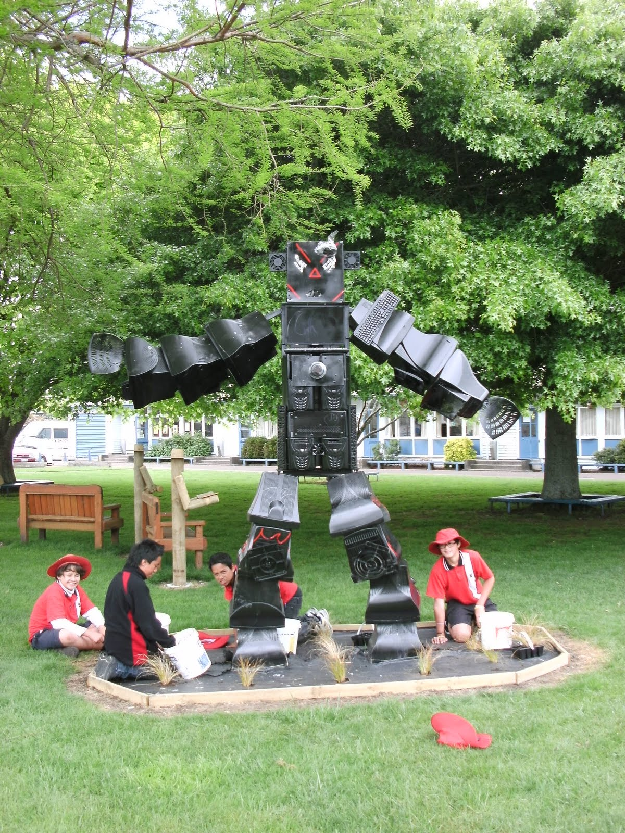

  - See blog

Parkvale School Hastings Wed 5 Oct
(Decile 5)
Parkvale School is where I started my teaching career in 1966 as a “probationary assistant” - a one year placement. I was curious to see what changes had occurred in the interim. The principal, Mark Gifkins, sets a very positive tone and is very engaged in the many activities the students are involved in. Recently all the Y5/6 students were engaged in yachting and kayaking. Y5/6 also attend annual school camps. Sport is a strong focus. Restorative Justice practices have gradually been introduced within recent years. The AP reports that this has had a very positive impact on the school.
It was interesting to note that although the admin block and classrooms appeared to be relatively modern to me, they have recently been reinforced to earthquake-proof them and are likely to be completely rebuilt by MOE when funding permits. HB is in an active earthquake zone.
Notes from the visit and discussion:
- As the principal was attending a conference, the AP hosted my visit. I greatly appreciated her very generous gift of her time and expertise on a typically busy day at the end of a very busy term. We sat in the principal’s office. School life is vividly reflected in many sporting-event photos printed in A4 size, on display on these office walls. A special accomplishment recently - a mixed team of Little Rippas participated in a tournament in Auckland, representing HB. A number of students popped in during our discussions, hoping to show the principal some work they were proud of.
- School motto is “Parkvale Pride” Everything that happens in the school is based around this motto and it is reflected in many displays and documents as well as the way students and staff relate to each other.
- The school is rich in ICT, pods of notebooks, sets of 8 - 10, also pods of ipads and ipods. The Library and computer lab are adjoining making it easy for teachers and classes to word collaboratively.
- There is ongoing coaching and PD provided - a high proportion of staff are very self-motivated and keen to use ICT resources effectively.
- The school had just hosted a parent evening to invite expressions of interest for Y5 and 6 students to be in digital classrooms next year. The cost will be $50 per month but students can also bring their own devices from home. Focus on podcasting and posting of work on school network, so it can be accessed by other classes. ICT is a major feature of school assemblies. Observed a very engaged and on-task group of students working in the ICT lab with a relief teacher.
- I briefly sighted some excellent documentation of school goals and systems, school wide planning etc.
- The principal is in a group of four principals who work with a high quality leadership consultant. The APs and team leaders are involved in some of the ongoing PD, which leads to shared understandings and coherence in leadership practice within the school.
- Professional Learning Communities: The school uses a coaching and mentoring model; focus on maths at present. There is a huge emphasis on mentoring and coaching to improve reflective practice.
- Largely Pakeha population but significant 21% of Maori students. See quote below, from recent 2011 ERO report: The school received a very positive report.
  - “How well are Māori students learning – engaging, progressing and achieving?
Overall, in 2010, the clear majority of Māori students achieved at or above in relation to the National Standards for reading, writing and mathematics and at a similar level to the whole-school population. Teachers use strategies such as cooperative learning and mentoring to support and improve Māori student achievement.
The school has reviewed its Māori achievement action plan based on the values of Ka Hikitia: Managing for Success/Māori Education Strategy. It continues the aim to raise Māori student achievement through the integration of te reo me ngā tikanga Māori within the classroom and school environment and to build closer relationships with the Māori community. The changes are in the early stages of implementation, but the plan's impact is evident in some rooms.”

Hastings Central School Wed 5 Oct
Principal: Alan McDonald. Acting principal: Sue Crombie
I chose to visit this school as I attended there as a pupil, from NE - Std 6 (in those days) and had very fond memories of my primary schooling.
The principal has been on Sabbatical this term, so I was hosted by the acting principal Sue Crombie. Sue was a very helpful and charming host who very willingly shared her ideas and experiences. The school roll is approximately 200, Decile 2, with 61% of the students being Maori and 20% Pakeha. Pasifika and Indian students make up most of the balance of the school.
Notes I made during the visit:
  - The school was having a special activity day with all students and staff being engaged in gardening. There was a busy, happy atmosphere throughout the school, with students clearly enjoying their practical work that would have a lasting positive impact on the school environment.
  - Sue has, as one of her responsibilities, that of SENCO. She maintains a folder on the server, each class has folder, each SN child has own folder, which includes scanned records, saves paper copies, similar for Reading Recovery. All the important data is on server, dated by year of completion. If record is no longer active, all that is retained is the observation summary. Classroom teachers have access to the folders. Confidential information is filed on SENCO laptop.
  - IEP MEETINGS: Teachers chair the meetings and update the IEPs, then send an electronic copy to SENCO who reads and files. Reduces workload for SENCO and empowers teachers. Limited number of students with IEPs.
  - Strong emphasis on ongoing PD and developing teachers as reflective practitioners. Local initiative to improve sharing between school: “Magic School Bus” involves four schools. All the staff travel from one school to another and visit all the classrooms showcasing classrooms / displays etc. Teachers available to answer questions etc. Finish off with wine & nibbles at the last school.
  - ECO school, chn and staff had a day of weeding and planting which was very structured and organized. One group of students had games they had written adapted by DOC and printed as a boxed game set. See website for a copy. School community very proud of their achievement.
  - An education hub for Hastings, Central, Kindergarten, (T's meet with KG staff regularly, Kick Start Programme from age 4 every Thursday afternoon. Makes for excellent transition, School for teenagers next door - those with behaviour issues etc, truancy service, RTLB, RTL's, Social worker (shared... One day per week)
  - Other features of the school include: Whanau centre in spare classroom, managed by parents, a large community garden, seed propagation area beside pool. Parents are taught “Reading Together" using prepared kits. Well resourced ESOL room which also contains Successmaker software, used on a pod of computers. Staff support from ESOL teacher.
  - Pods of notebooks available.
  - Beautiful foyer displays. School built approx. 1870. Although it has been modernized in some ways it still retains much of the character of the original buildings.
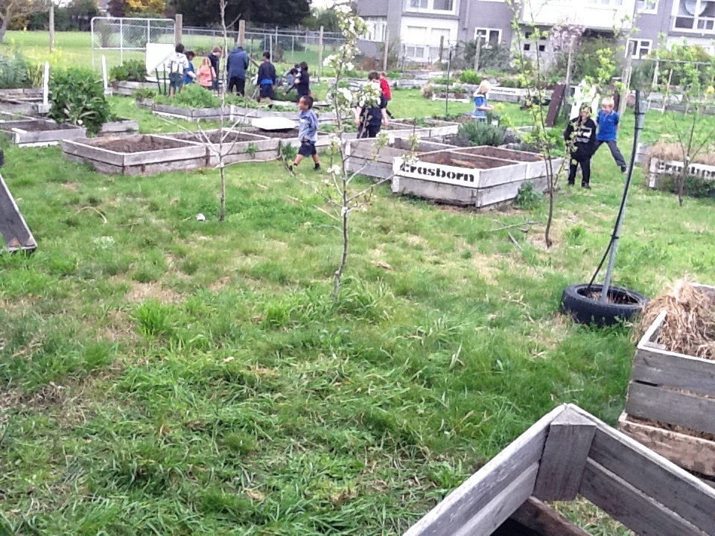
Hastings Central School Community Gardens
Summary and Conclusions
I would like to start by expressing my very sincere appreciation to the Board of Trustees of Stanhope Rd School for approving my application and then being very supportive once it was approved. I would also like to thank Jo Wison, acting principal - in my absence - and all the staff, for keeping the school running so smoothly while I was away.

I would also like to thank the NZEI for having successfully negotiated the Principal Sabbatical Leave Scheme. In the same vein I would like to express my appreciation to the Ministry of Education for its generous support of the scheme. It is a very flexible scheme. It allows each successful applicant to design a sabbatical experience that suits his or her own needs and experience level.

On reflection, I would have liked to have had this incredible experience a little earlier in my career, as I had been a principal for twenty-four years before I went on sabbatical. I feel that principals need a chance to refresh and revitalize on a reasonably regular basis, because of the demands and importance of the job we do and the amount of sheer energy it takes to keep a school growing and developing over time.

I found the ten weeks away from my school, gave me a very valuable chance to pause and reflect and look at what I was doing, within my role, with fresh eyes. I also felt I could see some of the issues and needs within the school more clearly. The chance to engage in in-depth discussions with colleagues, in a wide variety of settings, enabled me to compare and contrast what I was already doing as an educational leader with what I would like to aspire to. It also helped me to think constructively about the overall leadership structures within my school and what changes could be made within the various constraints that already existed - such as staffing entitlements and budgets.

On my return to Stanhope Rd School, I felt refreshed and that I had regained my old sense of humour. It enabled me to get through a very challenging, severely shortened 4th term (Rugby World Cup year) and make a number of needed changes before the end of the year, in preparation for the new school year. Although I subsequently decided to retire at the end of Term 1 and therefore was not able to completely follow-though on the many valuable ideas I picked up during my sabbatical, I feel that the changes implemented in 2012 were very worthwhile and that in the long term they will result in improved leadership throughout the school.
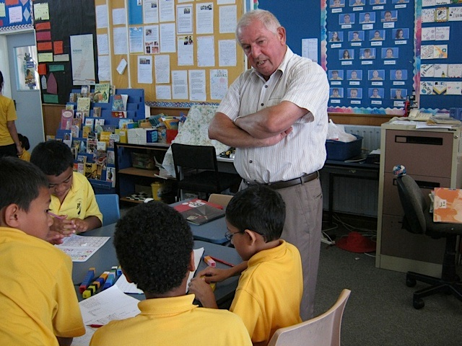
Cyril Nevezie with students from Stanhope Road

